Techniques for Improving Critical Thinking Skills
Critical thinking is an important tool for anyone who’s interested in becoming a consultant, working in the IT industry, or having a career working with large amounts of data. At its core, critical thinking is the ability to look at facts and data to understand a problem. In business, it’s important to go beyond a stated problem to get to the root cause of the actual issue. The following steps can improve your critical thinking skills:
- Question assumptions: It’s important to question assumptions—both your own, and those of others. Ask yourself, “Why do I have this opinion? What are some alternative perspectives that I could consider?” It’s possible to fall into a pattern of going with what you already know and repeating the same mistakes. By questioning the basis for your beliefs (and others’ beliefs) about what should be done, you can help make sure that you’re pursuing the correct course of action for the given problem. Questioning assumptions can also help you avoid group think, which is when you make mistakes because you surrounded yourself with only people who think similarly to you.
- Critically analyze data: When you look at large datasets, it’s possible to unconsciously look for information that confirms your own opinions. Each person has their own way of looking at the world, and will take information and filter it through that lens. Make sure that you also look for data that disproves the point you’re trying to make. Doing so can help uncover bias in your problem-solving process.
- Strategy games: Playing strategic games such as chess, Sudoku, or other board games can help you develop your critical-thinking skills. These kinds of games put you in a position where you need to think multiple steps in the future and consider many alternatives, all at the same time. This type of thinking can be valuable in the business world when you start designing solutions for a work problem because things will rarely go exactly as you expect them to.
- Collaborate: Seeking out others to work with can expose you to new ways of thinking. No two people will approach a problem in the exact same way, and this diversity of thought can help improve your own problem-solving process.
- Keep learning: Continually learning new things can help expand your critical-thinking skills. By always looking for new information, you can avoid using the same patterns of thinking. Try looking for new books or experts in your area of focus to seek out this information.
- Active listening: When you have conversations, make sure that you’re focusing on what other people are saying, instead of only waiting for your turn to speak. By actively listening, you’re more likely to gain insight into how to handle an issue in ways that you might not have thought of yourself.
Continued practice
Practicing your critical thinking skills is a lifelong process. You won’t reach a point where they’re perfectly developed and there’s nothing left to work on. This skill, like any other skill, can start to fade if it’s not used on a regular basis. One good way to make sure that you’re continually working on your critical thinking skills is to journal the problems you faced during the day. Journaling can help you reflect on the choices that you made, and it can also give you time to step back and reflect on the other paths that you didn’t take. Improving your critical thinking skills is a lifelong process, and one that can help you both in the business world and in your personal life.
Here’s how you could apply the working backwards technique to the presentation scenario, broken into clear steps:
🎯 End Goal
- Deliver a polished presentation at the business meeting that highlights replacing inefficient processes with cloud solutions.
📝 Presentation Review
- Schedule a final run-through to check flow, timing, and clarity.
- Ensure slides are error-free and aligned with the meeting’s objectives.
📊 Visuals & Data
- Create charts, diagrams, and visuals that illustrate inefficiencies and demonstrate cloud-based improvements.
- Double-check that data sources are credible and up to date.
🔍 Research & Content
- Gather case studies, statistics, and examples of successful cloud adoption.
- Identify current inefficiencies in processes and map them to cloud-based alternatives.
⏳ Preparation Timeline
- Allocate time for drafting slides, refining content, and rehearsing delivery.
- Set interim deadlines (e.g., research completed by Day 2, visuals by Day 3, rehearsal by Day 4).
Here’s a structured reflection using the decision-making with data lens:

📌 Decision Example: Buying a Car
1. Data Sources Used
- Online reviews & ratings (expert car review sites, YouTube comparisons).
- Fuel efficiency statistics (official manufacturer data, government mileage ratings).
- Cost breakdowns (dealer quotes, insurance premium estimates, maintenance costs).
- Resale value trends (used car market listings, depreciation charts).
- Personal budget spreadsheet (monthly affordability analysis).
2. How I Analyzed the Data
- Compared models side by side in a table (cost, mileage, safety ratings, resale value).
- Ran scenarios in Excel to see long-term costs over 5 years.
- Weighted factors: safety (highest priority), fuel efficiency, then resale value.
3. Conflicting Data Sources
- Manufacturer claimed higher mileage than real-world user reviews.
- Dealer emphasized discounts, but insurance quotes showed higher premiums for that model.
4. Data vs. Initial Reaction
- Initially wanted a sporty model based on looks and instinct.
- Data showed it had poor resale value and high maintenance costs, which conflicted with my gut feeling.
5. Consultation Before Final Decision
- Spoke with a trusted friend who owns a similar car.
- Asked family for input on budget comfort.
- Consulted an insurance agent for premium verification.
6. What I Would Change If Deciding Again
- Test drive more models before narrowing down.
- Collect maintenance cost data from actual owners rather than relying only on dealer estimates.
- Start with budget constraints first, then shortlist cars, instead of looking at all options.

This exercise shows how data-driven decision-making can override instinct and lead to a more sustainable choice.
Techniques for Gathering and Analyzing Information
As a cloud consultant, you can expect to guide customers in cloud-related decisions. Therefore, you must have strong skills for collecting and carefully assessing business information. This reading offers information about various techniques (which are grouped into three categories) that can help you in this process.
Category 1: Identifying challenges and goals
When you meet with stakeholders, you first need to understand what they are trying to achieve. To identify their requirements, challenges, and expectations, you can use these techniques:
- Interviews: Engage in direct conversations with stakeholders to gather requirements.
- Surveys: Share a questionnaire with the larger group to collect input about current challenges and desired features.
- Brainstorming: Promote an open discussion to generate innovative ideas.
Category 2: Evaluating business and setting objectives
After you identify areas that require changes, your next step is to assess how the business works in its current state and what you can do to improve it. As part of this task, you might consider reviewing business use cases and completing an analysis of systems, software, user experience, and other components. This information can help you design new systems that are better, faster, and more efficient:
- Use cases: Create a narrative of how a system or application is used in a real-world situation.
- System documentation: Review technical documentation, manuals, and architectures to understand how different components work together.
- Machine and software performance analysis: Evaluate the performance of hardware and software components.
- Interface analysis: Examine how stakeholders and users interact with different components.
- Cost analysis: Evaluate current and potential expenses associated with the project.
- Strengths, weaknesses, opportunities, and threats (SWOT) analysis: Assess strengths, address weaknesses, find new opportunities, and consider potential threats within the current state of the infrastructure.
- Benchmarking: Compare performance metrics against industry standards or competitors to achieve similar or better results.
Category 3: Designing and reassessing the model
Before you finalize project deliverables, you need to make sure that all components work as intended and that there are no potential issues that might prevent customers from achieving their goals. Therefore, during this step, you might build a preliminary model of the system. Some of the techniques that can help you at this stage include the following:
- Prototyping: Create a simplified model of the system or application to demonstrate functionality and refine feedback from stakeholders.
- Scenarios: Create hypothetical situations to predict how a new system might perform under different conditions, and explain how the business might respond in those situations.

Email Communication in a Business Setting
In this course, you learned about the power of communication in a professional setting. You can use different methods to collect information and express your thoughts. You might need to meet stakeholders in person, have conversations over the phone or through video calls, and provide details through email messages.Email communication remains a highly preferred method for sharing decisions, agendas, or formal documents. With email messages, you can keep track of communication and make it possible for teams in different time zones to respond at their convenience. Though email communication offers a range of benefits, it’s important to know how to use it correctly. You can incorporate the following essential elements of email communication:
Know your audience
Before you start an email conversation with a customer, research your audience. Then, adjust your tone and voice depending on your audience and the level of formality. Consider cultural differences. In some countries, people place a strong emphasis on formal language, while in others, people might be more relaxed and informal. For example, in an informal setting, you can generally address the group by saying “Hello everyone” or “Hi team” followed by a comma. Similarly, you can personalize your greeting by using the recipient’s name. In a more formal setting, include the recipient’s title (such as Mr., Ms., or Dr.), along with the last name.
Be informative and concise
Keep your email messages informative, clear, and concise. Make sure your email messages include all the necessary information so that the recipients don’t need to request additional details. For example, if you are setting up a new meeting, you can provide a meeting agenda, set expectations, propose the date and time, and include the location. If you send an email message after the meeting, you can provide the summary of the conversation, request additional information, and manage outstanding tasks so that everyone is on the same page.
Use subject lines
Another good way to make your email message stand out is by adding a clear, concise, and descriptive subject line. The main purpose of the subject line is to indicate the topic of the email message and get the recipient’s attention. Some subject lines could be “Cost Optimization and Performance Review” or “The Cloud Migration Strategy Meeting Summary.”
Indicate attachments and links
Some browsers might have features or settings that hide attached files. If you are sharing the documents with the team or providing links to external resources, let your audience know. Also, make sure that the attachments are relevant and bring value to the conversation.
Use a signature
Consider adding a professional signature at the end of the email message. Many email clients have built-in features to design a signature and enable an automatic signoff. Your signature might include your full name, position, company name, contact number, logos, and any other helpful information.
Proofread before sending
Always proofread your email messages before you send them. Make sure your email message doesn’t have any spelling errors, grammar errors, and slang. Simple mistakes and informal expressions can impact your professional posture.
Respond within appropriate time
The response rate to an email message might differ depending on the nature of the message itself. For urgent messages, you might need to reply immediately. However, for other non-urgent requests, it’s typical to respond within a few business days. To provide the best-quality service, you might consider setting communication expectations with your customers in advance. Additionally, you can enable automatic email responses if you are traveling or have other urgent commitments.

Designing a Solution
When you design a solution for the problem that you’ve been assigned, you need to go through two main steps. The first step is scoping the solution. In this step, you need to sort through the available data and figure out what information is relevant to the problem you want to solve. In the next step, you need to start architecting the solution in a way that you can present publicly. In this reading, you’ll learn about both of these steps so you can get the knowledge you need to start designing your own solutions.
Part 1: Scoping the solution
When you begin a project, online AWS resources can provide you with a place to start your work from. For example, if you need to build a web application to serve your customer’s content, a three-tier architecture would solve most of your issues. You’d need to customize it for your customer’s needs, but the basic pattern could serve as the foundation for your solution. The following resources can help you get started with your project:
- AWS Solutions Library
- AWS Whitepapers & Guides
- Getting Started with AWS
When you are going through these resources, it’s important to keep your original problem in mind. You need to take the solutions that are presented in these resources and change them to fit the needs of your customer. These resources are a good place to start, but they can’t design your solution for you. When you scope your solution, it’s also important for you to think as far into the future as you can. Can you foresee any potential issues with your solution? Are the dependencies for this project going to work with the solution you’re designing? Is the team that’s going to support this application willing and able to handle the solution you’re building when you move on to another role?
Part 2: Architecting
After you scope the solution to your customer’s problem, the next step is to create the architecture that you’ll use. In this stage, you design the solution that will be built and present it to the team that will be working with these resources. The AWS Well-Architected Framework is a tool that can help you with the architecting process. The Well-Architected Framework is a set of six pillars that can help you build secure, high-performing, resilient, and efficient infrastructure for a variety of applications and workloads. The design principles of the Well-Architected Framework can help guide you in creating the best possible solution for your customer’s problem. When it's time to present your solution, you need to have an architecture diagram to show your stakeholders the solution that you’ve put together. You can use the official AWS Architecture Icons to design a diagram of the solution, and you can also use this architecture diagram as a roadmap for your work going forward. The AWS Architecture Icons website also contains links to the drawing tools that are recommended by AWS to help you create architecture diagrams.

Here’s how you could structure your project deliverables using the Kanban board method:

🗂 Project Example: Reorganizing Office Space
1. To Do (Planned Deliverables)
- Declutter desk and shelves – remove unused items.
- Sort documents – categorize into “keep,” “scan,” and “discard.”
- Create storage system – purchase or repurpose boxes/folders.
- Plan layout – decide desk, chair, and equipment placement.
2. In Progress (Currently Working On)
- Scan important papers – digitize and upload to cloud storage.
- Rearrange furniture – implement the new layout plan.
3. Done (Completed Deliverables)
- Dispose of unnecessary items – recycle or shred.
- Set up digital folders – organize scanned documents.

⏳ Deadlines
- Declutter desk and shelves → by Day 1
- Sort documents → by Day 2
- Create storage system → by Day 3
- Plan layout → by Day 4
- Rearrange furniture → by Day 5

🔄 Progress Monitoring
- Move sticky notes from To Do → In Progress → Done as tasks advance.
- Review the board daily to ensure deadlines are met.
- Adjust priorities if unexpected tasks arise.

This way, you break the project into manageable deliverables with clear deadlines and a visual workflow.

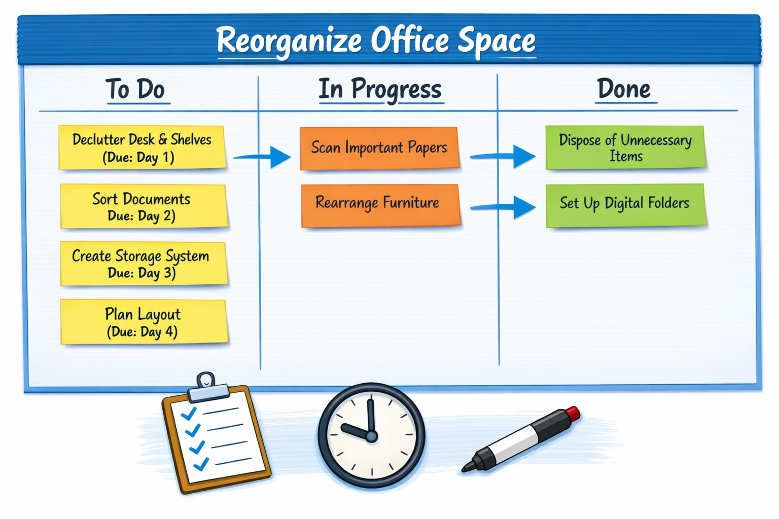

Optimizing Cloud Processes and Resources Over Time
The only constant in IT is change. Technology evolves at a rapid pace, and as a cloud consultant, you’ll need to keep up with this change. Clients and coworkers will be relying on you to advise them on what the next version of their architecture should look like. In this reading, you explore how you can optimize your cloud architecture and processes as the IT world continues to change.
Staying up to date
One of the most difficult parts of working with AWS is how frequently things change. Because AWS offerings can go through many updates and changes, it can be a challenge to keep up with what’s going on in the AWS Cloud on a day-to-day basis. One way to stay up to date is by following the AWS News blog, an official blog published by AWS about all of the ongoing updates in the AWS Cloud. The articles here could range from a new type of Amazon Elastic Compute Cloud (Amazon EC2) instance coming online, to the launch of a completely new service, or even the creation of a new Region. We recommend making this blog a weekly stop to keep up to date on new AWS releases.
Optimizing your architecture
As the cloud changes, you will need to perform a balancing act between maintaining the stability and consistency of your environment, and updating your architecture to get the most out of AWS. It might be tempting to upgrade everything in your environment the moment that a new feature or service is available to you. However, doing so can cause long-term problems with the compatibility and serviceability of your resources. When you see an opportunity to upgrade resources and you think it would be beneficial, try implementing the upgrade in a small testing environment. You can see if the upgrade benefits your resources, and you also have a chance to test its compatibility with your application. If an issue occurs, you can roll these changes back because they won’t affect the production resources. When you propose changes or updates, it’s also important to communicate to the teams that would be affected by these changes. You need to take their needs and timelines into account before you decide to make any updates. For example, if the team has an important deadline that they’re trying to meet next week, you should probably hold off on trying a new instance type in their environment.
Perfection is the enemy of good
Your architecture doesn’t need to be perfect when you first roll it out. Sometimes, you need to make compromises to make sure that your solution gets launched. Imagine that you’re migrating a database from a physical server into AWS. After meeting with the team, they express interest in using an Amazon Aurora Serverless database, but they’re currently on a different database engine, such as MySQL. You could take the time to migrate to the Aurora Serverless database engine when the team first moves off of the physical hardware. However, changing database engines would be a large change for the team to deal with. Instead, a more reasonable plan would be to migrate the database first to MySQL on Amazon Relational Database Service (Amazon RDS), and then see how the migration goes. From there, you can plan to migrate the MySQL database to Aurora Serverless after the team confirms that everything is working correctly, and that they’re ready for the next large change. You don’t need to build a perfect architecture on your first try. Remember that you often have the time and room to improve the solution that you’re creating.

Here’s a structured way to define your unique value proposition as a cloud consultant, using the prompts provided:

⚙️ Technical Proficiency
- Cloud Platforms: Experienced with AWS (Lambda, API Gateway, RDS, DynamoDB), Azure fundamentals, and Google Cloud basics.
- Best Practices: Familiar with the AWS Well-Architected Framework (security, reliability, performance, cost optimization).
- Automation Tools: Skilled in Python scripting, Google Apps Script, and CI/CD pipelines for deployment automation.
- Solution Design: Designed and optimized cloud-based reporting systems and identity verification workflows using computer vision APIs.
- Hands-On Experience: Built proof-of-concepts in hackathons and labs, including serverless applications and automated ETL pipelines.
- Technical Assistance: Helped colleagues migrate Excel-based reporting to cloud dashboards, reducing manual effort by 70%.

🌐 Soft Skills, Expertise, and Value
- Communication: Strong at translating technical concepts into executive-friendly presentations.
- Leadership: Guided cross-functional teams during migration projects, ensuring compliance and smooth adoption.
- Certifications & Courses: Completed AWS training modules, IBM certification prep, and cloud migration workshops.
- Problem-Solving Example: In one project, identified gaps in a contract’s cloud SLA terms, added client protections, and ensured smoother vendor negotiations.
- Feedback Integration: Used peer and mentor feedback to refine documentation style, making reports more concise and impactful.
- Continuous Learning: Stay updated through AWS News Blog, webinars, and hands-on labs.

💡 Stories & Values That Set You Apart
- Customer-Centric Approach: Always advocate for client-friendly solutions, balancing cost efficiency with reliability.
- Process Optimization: Known for spotting inefficiencies and replacing them with scalable cloud solutions.
- Trust & Reliability: Testimonials from colleagues highlight your ability to deliver robust, production-ready solutions under tight deadlines.
- Adaptability: Blend of technical depth and consulting skills makes you effective in both design and client-facing roles.

This list can serve as a foundation for interviews, client conversations, or LinkedIn branding. It highlights both your technical expertise and consulting mindset.
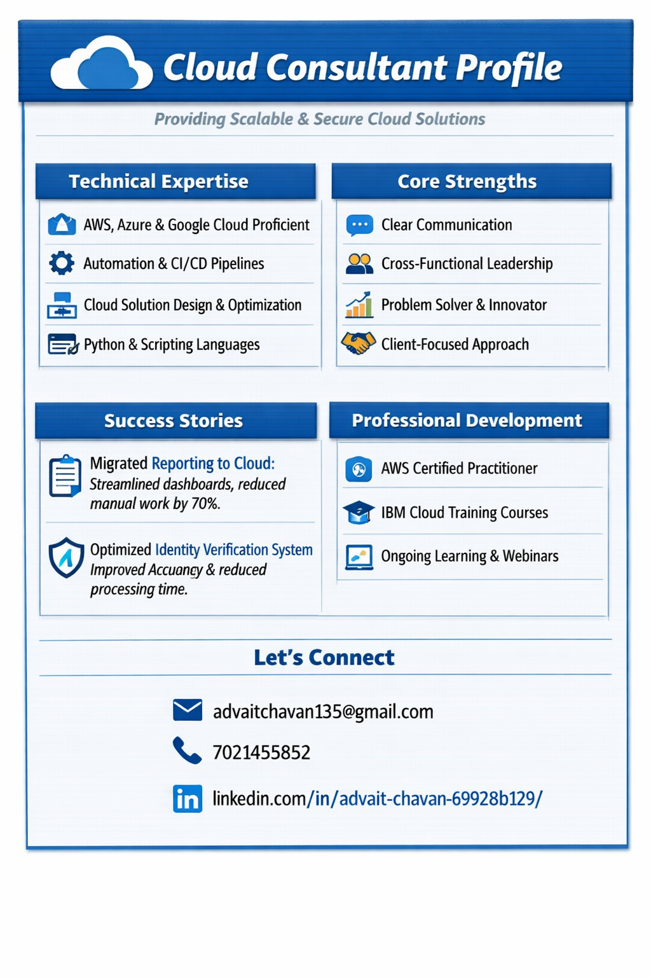
Opportunities for Professional Development
As you continue to grow your IT skill set, it’s important to recognize that this task is never finished. Because IT is constantly changing, you also need to change. In this reading, you learn about some resources that you can use to continually grow your technical skills and maintain your edge in the job market.
AWS Certifications
Getting an AWS Certification is a good way to show prospective employers or clients that you have a guaranteed set of skills in the cloud. Almost every technical discipline has a corresponding AWS Certification. However, if you’re new to certifications, you should consider the following two certifications first.
The AWS Certified Cloud Practitioner certification validates foundational, high-level understanding of the AWS Cloud, services, and terminology. This certification is a good starting point for individuals with no prior IT or cloud experience who want to get started on the AWS Certification journey.
After you attain AWS Certified Cloud Practitioner—or if you already have some background in the AWS Cloud—the next step is the AWS Certified Solutions Architect Associate exam. This certification showcases knowledge and skills in AWS technology, across a wide range of AWS services. The focus of this certification is on the design of solutions that are optimized for cost and performance, and demonstrating a strong understanding of the AWS Well Architected Framework.
AWS Skill Builder
Whether you’re working on a certification or trying to learn about a new AWS service, AWS Skill Builder can help you reach your goal. AWS Skill Builder is training platform that AWS built so AWS customers can learn about the latest AWS services.
To learn about the courses that you can take, select an IT job role or a technical area of focus from the main page of the learning platform. Skill Builder also offers free preparation material for AWS Certifications, if you’re interested in practicing for your AWS Certification exam.
AWS events and webinars
Though reading documentation can be very helpful, it’s sometimes best to hear directly from the experts. AWS offers both free and paid events and webinars that cover various topics.
These events range from a free online course that walks you through the Well Architected Framework to the annual AWS re:Invent conference in Las Vegas. AWS also offers a variety of meetups throughout the year around the globe. We recommend following this site to see if there are any upcoming events that would be useful to your professional development.
AWS re:Post
If you’re looking for tips, tricks, or help with a project from AWS experts and community members, you should explore AWS re:Post.
AWS Re:Post is a forum where you can communicate with other AWS users and gather to talk about what’s happening in the cloud. The website is broken up into topics, or areas of focus. These topics cover a wide spectrum of the cloud, and are a good resource if you run into problems when you build your architecture on AWS.

Time Management Techniques
Imagine a day without any plan or schedule. You might find yourself rushing, feeling overwhelmed, and struggling to get things done. In contrast, when you manage your time well, it can be similar to having a clear roadmap. You know what needs to be done, and when. This knowledge can help you be more efficient, calm, and focused. Time management is a well-known skill that can help you improve your productivity, reduce stress, build trust, and create a better balance between your work and personal life. With this skill, you can consistently meet deadlines, learn something new, and make the most out of every moment.To practice time management, you can consider the following techniques:
- Creating a to-do list: This technique requires listing and organizing all the tasks you plan to accomplish. By visualizing what you need to do, you can prioritize tasks and track your progress.
- Prioritizing (Eisenhower Matrix): This technique is known as the Eisenhower Matrix. It involves categorizing tasks based on their urgency and importance. After you prioritize tasks, you then allocate time and energy to handle the time-sensitive items first.
- Setting goals: With this technique, you set clear and specific goals for each task. These goals must be specific, measurable, achievable, relevant, and time-bound (SMART).
- Automating routine tasks: This technique uses technology to automate repetitive tasks. By using automation, you can free up your time to focus on tasks that add value.
- Blocking time: This technique helps you minimize distractions by allocating specific blocks of time to tasks that require focus.
- 80/20 rule (Pareto principle): This technique highlights the importance of identifying and prioritizing the most impactful tasks. According to this technique, approximately 80 percent of outcomes come from 20 percent of effort. This principle implies that, by focusing on the most valuable tasks, you can achieve higher results with less effort.
- Eliminating meaningless activities: This technique requires eliminating or minimizing tasks that decrease your productivity. These tasks might include social media browsing, unproductive meetings, or multitasking.
- Reflecting: With this technique, you assess how effectively you manage time, and then adjust the techniques based on what works best for you.
Time management can help you take control over your time and achieve goals with greater efficiency. You can start with one technique, and then incorporate new ones as they become part of your routine.
Designing a Resume
A resume is a brief overview of your education, skills, work experience, achievements, and other relevant qualifications. Typically, a resume consists of one or two pages. If you have limited work experience, it’s best to use a single-page template with clearly defined sections. These sections can highlight your skills, accomplishments, internships, volunteer work, and personal projects. Additionally, you can tailor content in each section to align better with the job you want.
Sections:
- Create sections to make different areas of your resume stand out. The sections might include contact information, summary, skills and expertise, experience, and education.
Contact information:
- Provide contact details, such as your full name, email address, and a phone number.
- Make sure that your email address sounds professional.
- Set up voicemail in case you miss a call.
- Avoid adding your photo and any personal information, such as your age, marital status, religion, and other details.
- If you are applying for a local job and you want to show the potential employer that you don’t require relocation, you can specify your city, state, or metropolitan area. Don’t provide your full mailing address.
Objectives or summary (optional):
- Highlight your most valuable expertise.
- Include your professional title, number of years of experience (if you have more than 2 years), proudest accomplishments, education or training, and skills that make you an excellent candidate for the job.
Skills:
- Include relevant technical skills. These skills can be your proficiency in programming languages and knowledge of cloud concepts, best practices, platforms, services, and tools.
- Include relevant soft skills, such as problem-solving, analytical thinking, project management, leadership, and more.
Education and professional development:
- Reference your highest level of education.
- Highlight your certifications and technical training.
- List additional courses and workshops that contributed to your growth.
Professional experience:
- Include the company name, your title, and the year or time period that you worked for them. If you don’t have professional work experience, outline your personal projects, internships, hackathons, or volunteer work that improved your knowledge in the field. Include only relevant information.
- List your experiences in chronological order, starting with the most recent job or project.
- Use a bulleted list to highlight your accomplishments and how you made a positive impact.
- Write between three to six bullet points for each project or job.
- Start each statement in the list with a verb, such as implemented, developed, created, or participated.
- Where possible, add quantifiers. Quantifiers can be action verbs, such as increased, reduced, saved, or generated, followed by a number. For example: Increased the customer satisfaction score by 40%.
- Include keywords and terminology from the job postings to make your resume more searchable by the application system.
General recommendations:
- Consider anything else that can help you stand out. Do you speak multiple languages? Have you presented at conferences or events? Do you have awards or recognitions?
- Don’t dive into too many details. Include only the most important and relevant information to keep your resume concise and clear.
- Avoid using personal pronouns, such as I, me, or mine.
- Spell out abbreviations that are not general knowledge.
- Avoid excessive graphics, images, and confusing layouts.
- Maintain a positive tone and avoid any negative language.
- Be honest about your experiences and accomplishments.
- Have a friend or family member review your resume and provide feedback.
- Proofread your resume before applying. Ensure that your language is free of errors and colloquial phrases.
- Imagine that a recruiter has only 10 seconds to view your resume. Take a holistic look at your resume to assess if it’s visually clear, consistent, and easy to read.
- Save your resume as a PDF to avoid formatting issues when you are applying for a job.
Additional resources
- 4 Steps Closer to Your AWS Cloud Career
- AWS Training FAQ
- New Courses and Certification Updates from AWS Training and Certification in September 2023

Here’s a resume checklist summary you can use to redesign and polish your CV so it stands out:

🖋 General Appearance
- Use a professional, easy-to-read font (Calibri, Arial, Verdana, Georgia, Times New Roman).
- Font size: 11–12 pt for text, 12–14 pt for section titles.
- Keep it 1–2 pages maximum.
- Align text to the left with even margins.
- Organize into clear sections: Contact Info, Summary, Skills, Experience, Education, Certifications.

📑 Content Essentials
Header
- Full name at the top.
- Phone number with area code.
- Professional email address.
- Optional: LinkedIn or portfolio link.
Summary (Optional)
- 2–3 lines highlighting achievements, expertise, and career focus.
Skills
- Technical skills (cloud platforms, automation, programming).
- Soft skills (communication, leadership, problem-solving).
- Optional: Languages with proficiency levels.
Education
- Highest degree, school name/location, graduation date.
- Relevant certifications (AWS, Azure, IBM, etc.).
Professional Development
- Relevant courses, workshops, projects.
- Only list what adds value to the role.
Experience
- Chronological order (most recent first).
- Include company name, location, job title, employment dates.
- 3–6 bullet points per role:
  - Start with action verbs (e.g., “Developed,” “Implemented,” “Optimized”).
  - Focus on achievements, not duties.
  - Use quantifiers (e.g., “Reduced costs by 20%”).
  - Include keywords from the job description.

✅ Final Review
- Resume is clear, consistent, and easy to read.
- No spelling or grammar errors.
- No images, photos, or private info.
- Highlights transferable skills and experiences.
- Tailored to the specific job role.
- Exported as PDF before sending.

This checklist ensures your resume is professional, tailored, and achievement-focused—exactly what recruiters look for.

